# Working with the Current Date and Time - Exercise (Updated)

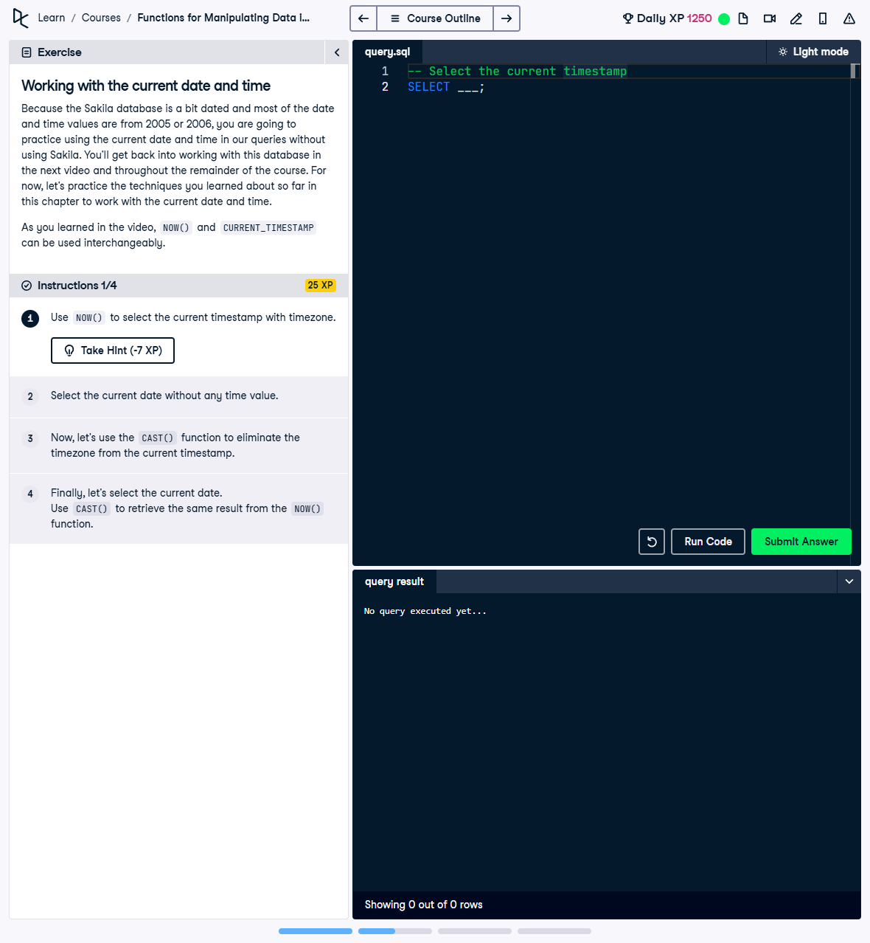

Question:

Practice using the current date and time in queries with the following steps:  
1. Use NOW() to select the current timestamp with timezone.  
2. Select the current date without any time value.  
3. Use the CAST() function to eliminate the timezone from the current timestamp.  
4. Use CURRENT_DATE and CAST() to retrieve the current date.

## Answer:

-- 1. Select the current timestamp with timezone  
SELECT NOW();  
  
-- 2. Select the current date without any time value  
SELECT CURRENT_DATE;  
  
-- 3. Use CAST() to eliminate the timezone from the current timestamp  
SELECT CAST(NOW() AS TIMESTAMP);  
  
-- 4. Use CURRENT_DATE and CAST() to retrieve the current date  
SELECT CURRENT_DATE, CAST(NOW() AS DATE);

## Explanation:

1. NOW(): Retrieves the current date and time, including timezone information.  
2. CURRENT_DATE: Returns only the current date without any time information.  
3. CAST(NOW() AS TIMESTAMP): Removes the timezone information from the current timestamp, leaving only the date and time.  
4. SELECT CURRENT_DATE, CAST(NOW() AS DATE): Retrieves the current date in two ways. CURRENT_DATE provides the date directly, while CAST(NOW() AS DATE) extracts the date part from the full timestamp.